EXP 6 : POWER SPECTRAL DENSITY (PSD) ANALYSIS OF PHASE MODULATED
(PM )SIGNALS USING MATLAB

SOFTWARE USED : MATLAB SOFTWARE

CODE :
clc; clear; close all

Fs=1e5; t=0:1/Fs:2e-3;
fm=1e3; fc=10e3; kp=pi/2;

m=cos(2*pi*fm*t); % Message
c=cos(2*pi*fc*t); % Carrier
PM=cos(2*pi*fc*t+kp*m); % PM signal

subplot(3,1,1),plot(t,m),grid on
title('Message Signal')

subplot(3,1,2),plot(t,PM),grid on
title('PM Signal')

subplot(3,1,3)
pwelch(PM,[],[],[],Fs,'centered')
title('Power Spectral Density of PM Signal')
xlabel('Frequency (Hz)'),ylabel('Power/Frequency')
grid on

MODEL GRAPH :
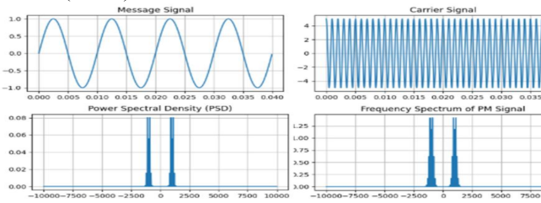

RESULT :
